FAITH BAPTIST CHURCH, ABEYEE
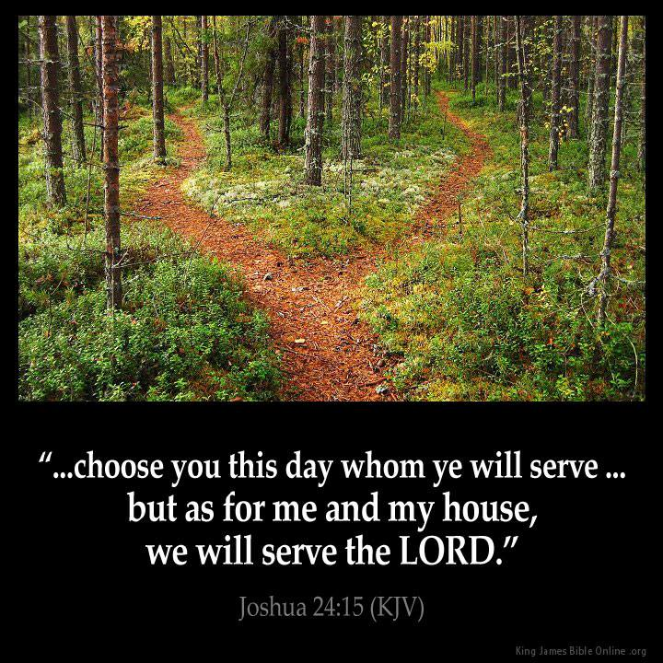
KINGDOM TEENS CAMP-2022

THEME: A CHOICE TO SERVE THE LORD
VENUE: FBC MISSION HOME, ABEYEE
DATES:
AGES: 8 YEARS +

Name:………………………………………………………………………………………….
Group:…………………………………………………………………………………….....
TIME TABLE
TIME | SUN | MON | TUE | WED | THUR | FRI | SAT
11:00pm-12:30am | WELCOME TO KINGDOM KIDS TEENS CAMP | DAWN PRAYERS
12:30am-4:30am | WELCOME TO KINGDOM KIDS TEENS CAMP | SLEEP
4:30am-6:00am | WELCOME TO KINGDOM KIDS TEENS CAMP | DAWN BROADCASTING
6:00am-7;00am | WELCOME TO KINGDOM KIDS TEENS CAMP | GROOMING |  |  |  |  | CHURCH & CAMP CLEANING
7:00am-8:30am | WELCOME TO KINGDOM KIDS TEENS CAMP | OPENING ASSEMBLY-LEARNING OF BIBLE PLEDGES, SONGS AND MORNING DEVOTION |  |  |  |  | CHURCH & CAMP CLEANING
8:30am-9:00am | WELCOME TO KINGDOM KIDS TEENS CAMP | BREAKFAST
9:00am-10:00am | WELCOME TO KINGDOM KIDS TEENS CAMP | MISSION TIME AND GOSPEL PRESENTATION-RINGU OF INDIA’S FOREST |  |  |  |  | PERSONAL GROOMING
10:00am-12:00am | WELCOME TO KINGDOM KIDS TEENS CAMP | CLASS TIME |  |  |  |  | PERSONAL GROOMING
12:00am-12:30pm | WELCOME TO KINGDOM KIDS TEENS CAMP | LAUNCH
12:30pm-2:00pm | ARRIVAL AND REGISTRATION | SIESTA
2:00pm-4:00pm | ARRIVAL AND REGISTRATION | GAMES |  | REHEARSALS
4:00pm-5:00pm | ARRIVAL AND REGISTRATION | GROOMING
5:00pm-5:30pm | SUPPER
5:30pm-8:00pm | ORIENTATION | CLOSING ASSEMBLY AND MOVIE SHOW-PILGRIM’S PROGRESS |  |  |  |  | CLOSING CEREMONY,REVIEW AND PARTY
8:00pm-11:00pm |  | SLEEP

CAMP TEAM
- Camp Director---Ps. Solomon Ackon
- Cook----Sis. Paulina
- Camp Registration and Protocol Officer----Sis. Grace
- Camp Teens Lead
  - Dinning---------Cecilia
  - Boys Adjutant-----Prosper
  - Girls Adjutant----Augustina
  - Commandant------Takyi
CAMP RULES AND REGULATION
- Obey the wakeup call
- Punctuality in class
- Dressing should be descent
- Throw all rubbish into dust bins
- Abide by all camp rules
- Avoid unnecessary argument, fighting, stealing, insulting etc.
- Must take part of all activities at the camp
- Bring a bible, jotter, color, pen or pencil to class everyday
- Approach any camp officer for any problem
- No phones will be at camp
BIBLE PLEDGE
I pledge allegiance to the bible,
God’s Holy Word.
I will make it a lamp unto my path feet,
And a light unto my path.
I will hide its words in my heart,
That I might not sin against God.

WELCOME AND CLOSING SONGS
Kingdom camp sure is fun
Bring your friends in one by one
Fill the place up way up
Fill it to the door
Then we’ll go and get some more

Our kingdom camp is over
And we are going home
Goodbye …!! Goodbye …!!
Be always kind and true
Goodbye …!!! Goodbye …!!!
We hope we’ll meet again

CAMP THEME SONGS
- Choose to serve the lord
Queen Esther’s story shows me that I can stand for right
Elisha taught that angels protect me by my side
Like David I can slay, Goliath in my way
Like Deborah, I can lead my friend to Christ

I will choose to serve the lord
Like my scripture heroes of old
As I learn and grow in faith,
God will be strength
With every step I take
I will choose to serve the lord

Like Moses I find courage, for God provides a way
Like Noah I will listen to heaven and obey
I’ll trust the lord, like Job and live with love and hope
Like Hannah God will hear me when I pray

Caleb was brave, Joseph forgave
Ruth stayed, Daniel prayed
Jonah changed

- We will serve the lord
We will serve the lord, even when trials come
No one can separate us from the love of God
We are more than conquerors, no one can defeat us
We’re such a chosen generation, we are sons of God

We will serve the lord
We will serve the lord
As for me and my house 2×
We will serve the lord

- I’ll stand for God
I’ll stand for God though the mountains fall
He’ll help me stand, I will stand up tall
When troubles come, he’ll be with me through it all
I’ll stand for God

I’ll stand for God though the mountains fall
He’ll help me stand, I will stand up tall
When friends forsake me, and I’m about to fall
I’ll stand for God

I’ll stand for God though the mountains fall
He’ll help me stand, I will stand up tall
Everyday I’m listening for His call
I’ll stand for God 3×

MISSION SONGS
- Stop and go
Stop and let me tell you what the lord has done for me
Stop and let me tell you what the lord has done for me
He forgave my sin and He saved my soul
He cleansed my heart and He made me whole

Go and tell the story of the Christ of Calvary
Go and tell the story of the Christ of Calvary
He’ll forgave their sins, He will save their souls
He’ll cleanse their heart, He will make them whole
Go and tell the story of the Christ of Calvary 2×

- Let’s get started
Let’s get started and tell of Jesus
Let’s get started, we must begin
To tell the whole world about our savior 2×
To tell the whole world about our friend

The time is now we can’t wait, the message cannot be late
That Jesus died for our sin, and that he rose again

Let’s get started and tell of Jesus
Let’s get started, we must begin
To tell the whole world about our savior 2×
To tell the whole world about our friend
Let’s get started!!!

- Children all around the world
There are children all around the world.. Children just like me
Children everywhere on earth, across the land and sea
They need to hear that Jesus died and lives to set them free
Who will go and let them know
Oh lord, send me

There are children in my neighborhood , children out to play
Children who have never heard that Jesus is the way
He died and came alive again and lives in heaven today
Help me go and let them know
O lord I pray

DEVOTIONAL SONGS
- Deep deep deep
Let’s discover, let’s explore
Your creation and so much more
It’s exciting, can’t wait to see
What you have in store
Surrounded by waves of your mystery
Lord, show me what you want me to be

Let’s go deep deep deep, Deep as the ocean
Deep deep deep, Deep in my faith with you
Deep deep deep, Deep in my heart I see
Your love is endlessly deeper than the sea
Let’s dive deeeeeeeeep!-(second time)

Let’s dive deep in our faith, Let’s dive deep in our walk,
Let’s dive deep in our trust, Let’s dive deep in our talk,
Let’s dive deep in your word, Let’s dive deep in your ways
Let’s dive deep in your love, Let’s dive deep every day!

- Did you ever talk to God above

Did you ever talk to god above?
Tell him that you need a friend to love
Pray in Jesus’ name believing that
God answers prayers!

Have you told Him all your hopes and fears?
Jesus cares about your joys and tears
You can know that He will always hear
And He will answer prayer

You can whisper in a crowd to Him
You can cry when you’re alone to Him
You don’t have pray aloud to Him
He knows your thoughts
On a lofty mountain peak He’s there
In a meadow by a stream He’s there
Anywhere on earth you go
He’s been there from the start

Find the answer in the word it’s true
You’ll be strong because He walks with you
By His faithfulness He’ll change you too
God answers prayer

Did you ever talk to god above?
Tell him that you need a friend to love
Pray in Jesus’ name believing that
God answers prayers!

- God creator king
Genesis 1:1, Genesis 1:1, Genesis 1:1 yeah!
In the beginning God created the heavens and the earth
In the beginning God created the heavens and the earth
The heavens and the earth, the heavens and the earth
In the beginning God created the heavens and the earth
In the beginning God created the heavens and the earth
Genesis 1:1, Genesis 1:1, Genesis 1:1 yeah!

CAMP REPORTING KIT

- Personal Grooming
Soap=1
Sponge=1
Toothbrush=1
Toothpaste=1
Towel=1
Bucket=1
Bathroom Sandals=1
Pomade=1
Deodorant=1
Comb /Hair Brush.=1

- Beddings And Wardrope
Pants/Underwears=3
Singlets/Semese=3
Complete Top&Down/Gown=5
Church Wear=1
Sandals/Shoe=1
Handkerchief=3
P.E Kit(Top & Down, Boot)=1
Socks=2
Toilet Roll=1
Bedsheet=1
Cloth=1
- Stationery And Materials
Clear Bag=1
Pencil=1
Eraser=1
Sharpner=1
Pen=1
Colour=1
Bible=1
Note=1
- Cutlery & Cockery
Cup=1
Plate=1
Spoon=1

CAMP MENU

Menu | Sun | Mon | Tue | Wed | Thur. | Fri | sat
Breakfast | Arrival | Hausa kooko & bread with margarine | Tea & bread with sandwitch | Fasting | Rice porridge &bread with margarine | Fasting | Tea & bread with sandwitch
Launch | Arrival | Bissab and biscuit | Rich gari mix and biscuit | Gari balls & pepper sauce with fried fish | Rich gari mix and biscuit | Gari balls & pepper sauce with fried fish | Bissab & bread
Supper | Gari & pepper sauce with fried fish | Ampesi & palava sauce with fried fish | Rice & stew with egg | Banku and kontomire stew with fried fish | Rice & stew with egg | Banku and kontomire stew with fried fish | Jollof rice & egg

CURRICULUM OVERVIEW
Lesson parameters | Monday | Tuesday | Wednesday | Thursday | Friday
- Lesson number | 1 | 2 | 3 | 4 | 5
- Lesson title: | A choice to Obey the lord | A choice to trust the lord | A choice to follow the lord | A choice to stand for the lord | A choice to serve the lord
- Focus Passage: | 1 Samuel 15:1-28 | Exodus 14:1-31 | 1 Kings 18:20-40 | Numbers 14:1-24 | Joshua 24:14-25
- Memory Verse: | 1 Sam. 15:22b”…  Behold, to obey is better than sacrifice,  and to hearken than the fat of rams. | Exodus 14:14  The Lord shall fight for you, and ye shall hold your peace | 1 Kings 18:21  And Elijah…said, How long halt ye between two opinions? if the Lord be God, follow him: but if Baal, then follow him. | Numbers 14:8  If the Lord delight in us, then he will bring us into this land, and give it us; a land which floweth with milk and honey | Joshua 24:15-  … choose for yourselves today whom you will serve…but as for me and my house, we will serve the Lord.
- Memory verse review technique | Animal actions | Hopscotch | Erase a word | Fill in the blanks | Active verse
- Teaching objective: | To understand the importance of obeying the lord. | To understand the importance of trusting the lord. | To be able to follow God during confusing situations of evil and good | To be able to stand for God even when all others are otherwise | To be committed to serve God in school, homes and church
- Main truth: | God delights in our obedience than our gifts or sacrifices. | In life’s difficult times, it is good to trust in the lord | It is the right choice to be on the Lord’s side than any other side. | If you choose to stand for God, He will also stand for you | God wants us to serve Him with our all
- Life Application | I can choose to obey the lord | I can choose to trust in the lord | I can choose to follow the lord | I can choose to stand for the lord | I can choose to serve the lord
- End of lesson review game | Hoop it up  (competition) | Team leader dress up  (competition) | Two steps forward and one step back  (competition) | Zonk  (competition)
- Reference: |  | Goodbye Pharaoh ppt | The man of fire ppt

CLASS TIME PRESENTATION SCHEDULE
- Songs, welcome and prayer -18min
- Theme song-2min
- Memory verse -10min
- Lesson song-4min
- Bible lesson and invitation-30min
- Life Application-5min
- Review game -10min
- Wonder time-5min
- Closing (announcements and prayers)-5min

Devotional outline
Ref: kids draw the bible devotion

Days | Morning | Evening
Mon | L-1: In The Beginning | L-2: Creation Completed
Tue | L-4: Sin Enters The World | L-5:God Sends His Son
Wed | L-22: Jesus Is Betrayed | L-23: Jesus Suffers
Thur | L-24: Jesus Dies | L-25: Jesus Is Buried
Fri | L-26: Jesus Comes Alive | L-27: Jesus Appears
Sat | L-29: Spread The Word | L-30: Be Ready

A CHOICE TO SERVE THE LORD

Lesson 1: A choice to obey the lord
Aim: To understand the importance of obeying the lord
Main truth: God delights in our obedience than our gifts or sacrifices
Passage: 1 Samuel 15:1-28
Memory verse
1 Sam. 15:22b… Behold, to obey is better than sacrifice, and to hearken than the fat of rams.

Wonder time fun game
Start with 1 and connect the dots to make a picture.
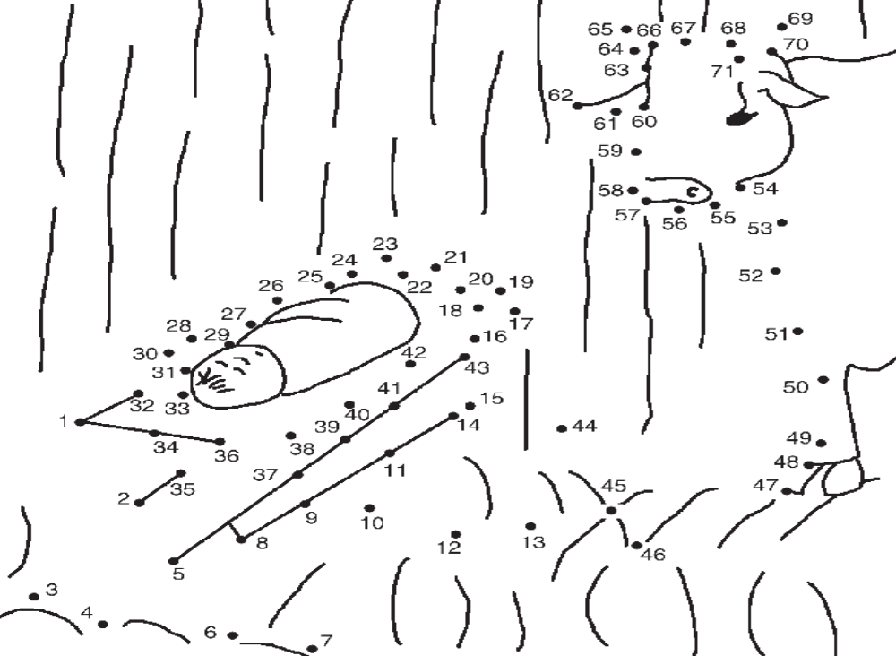

A CHOICE TO SERVE THE LORD

Lesson 2: A choice to trust the lord
Aim: To understand the importance of trusting the lord
Main truth: In life’s difficult times, it is good to trust in the lord
Passage: Exodus 14:1-31
Memory verse
Exodus 14:14. The Lord shall fight for you, and ye shall hold your peace
Wonder time fun game
Follow the maze to move from the closed tomb to the picture of Jesus alive.
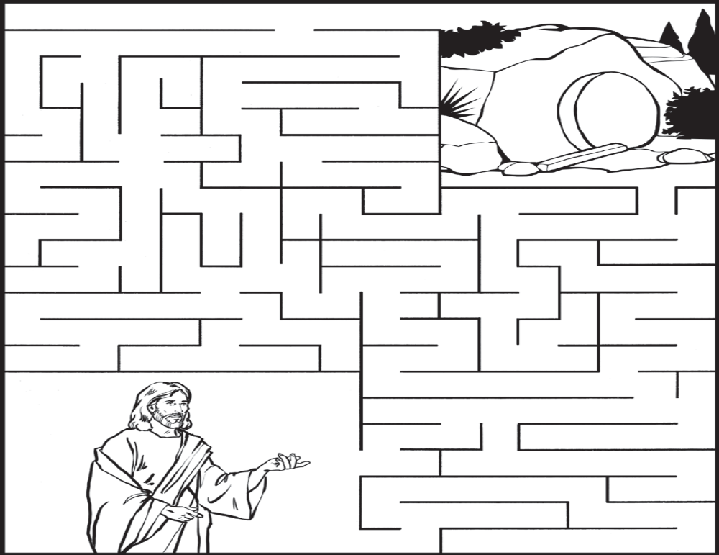

A CHOICE TO SERVE THE LORD

Lesson 3: A choice to follow the lord
Aim: To be able to follow God during confusing situations of evil and good
Main truth: It is the right choice to be on the Lord’s side than any other side
Passage: 1 Kings 18:20-40
Memory verse
1 Kings 18:21. And Elijah…said, How long halt ye between two opinions? if the Lord be God, follow him: but if Baal, then follow him.
Wonder time fun game
Color the spaces by number. 1 = red 2 = green 3 = blue 4 = yellow
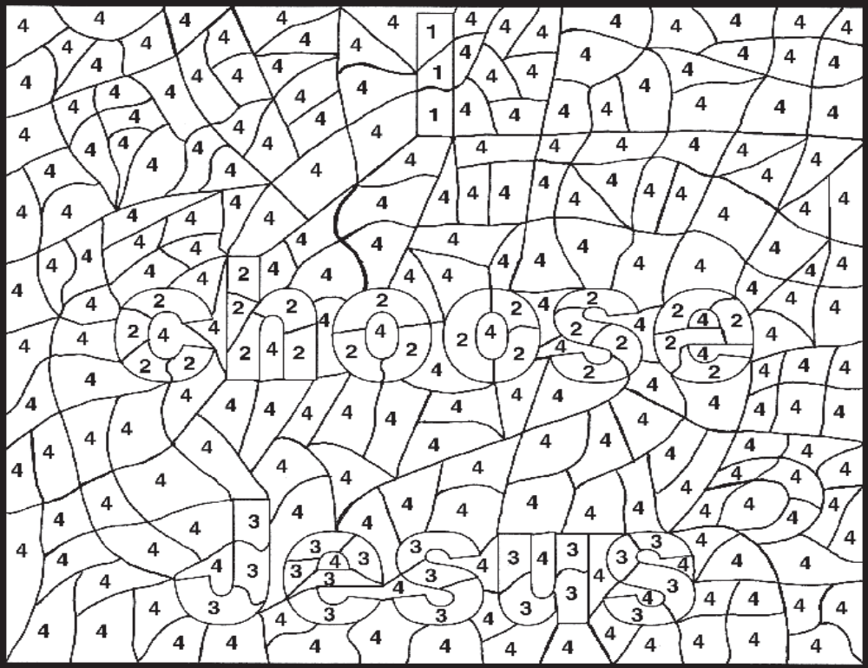

A CHOICE TO SERVE THE LORD

Lesson 4: A choice to stand for the lord
Aim: To be able to stand for God even when all others are otherwise
Main truth: If you choose to stand for God, He will also stand for you
Passage: Numbers 14:1-24
Memory verse
Numbers 14:8. If the Lord delight in us, then he will bring us into this land, and give it us; a land which floweth with milk and honey
Wonder time fun game
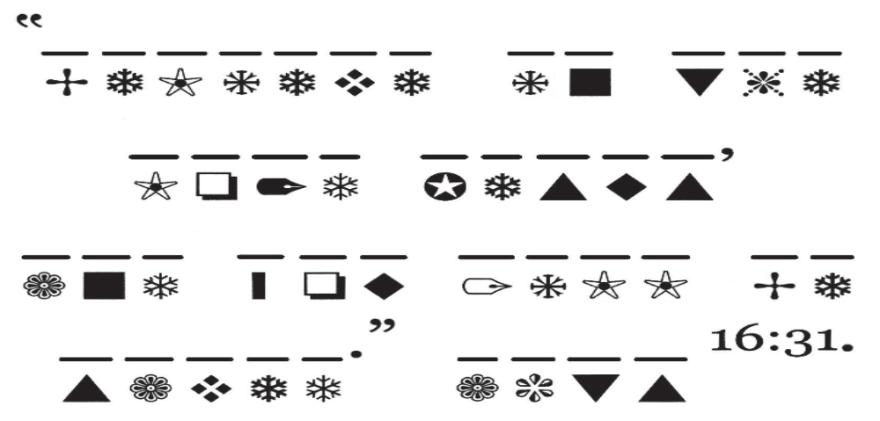
Use the code below to solve the Bible puzzle above.
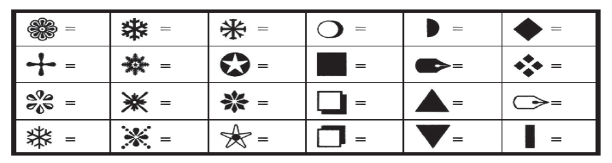

A CHOICE TO SERVE THE LORD

Lesson 5: A choice to serve the lord
Aim: To be committed to serve God in school, homes and church
Main truth: God wants us to serve Him with our all
Passage: Joshua 24:14-25
Memory verse
Joshua 24:15 … choose for yourselves today whom you will serve…but as for me and my house, we will serve the Lord.
Wonder time fun game
Color the spaces with the right colors to see what God wants your life to be like.
• = red • • = blue • • • = green

DAILY BREAD
DAYS/TIME | MORNING | AFTERNOON | EVENING
MONDAY | 1 Sam. 15:22b… Behold, to obey is better than sacrifice, and to hearken than the fat of rams. | Genesis 1:1  “In the beginning God  created the heavens  and the earth.” | Deuteronomy 6:5  “Love the LORD  your God with all  your heart.”
TUESDAY | Exodus 14:14. The Lord shall fight for you, and ye shall hold your peace | 1 Corinthians 15:3  “Christ [Jesus]  died for our sins.” | 1 John 4:14  “The Father has sent  his Son to be the  Savior of the world.”
WEDNESDAY | 1 Kings 18:21. And Elijah…said, How long halt ye between two opinions? if the Lord be God, follow him: but if Baal, then follow him. | 2 Timothy 1:8  “So do not be  ashamed to testify  [tell or show] about  our Lord [Jesus].” | 1 Peter 2:21  “Christ suffered  for you.”
THURSDAY | Numbers 14:8. If the Lord delight in us, then he will bring us into this land, and give it us; a land which floweth with milk and honey | Acts 16:31  “Believe in the  Lord Jesus, and you  will be saved.” | Colossians 2:13  “He [God] forgave  us all our sins.”
FRIDAY | Joshua 24:15 … choose for yourselves today whom you will serve…but as for me and my house, we will serve the Lord. | Matthew 28:6  “He [Jesus] has risen,  just as he said.” | John 20:29  “Blessed [happy] are  those who have not  seen [Jesus] and yet  have believed.”
SATURDAY | Acts 1:8 “You will be  my witnesses.” | Matthew 28:20  “I am with you  always, to the very  end of the age.” | Matthew 24:44  “So you also must be  ready, because the  Son of Man [Jesus]  will come.”

ACTIVITIES:
- REHEARSAL PLAN AND ACTIVITIES
- CHILDRENS DAY ORGANISATION
  - Outline
- Opening prayer
- Opening hymns
- Praise and worship
- Dance choreography
- Sermon
- Offertory
- Announcement
- Closing hymns
- Benediction and closing

- GAMES PLAN
- Lime in spoon race
- Pearl in bowl
- Sack race
- Scarefold-finding

- STAKEHOLDER ENGAGEMNT
  - CHURCH
    - Announcements
    - Food items and resources support
  - CHILDREN MINISTRY HELPS
    - Meetings with mad. Paulina and grace
    - Food items and resources help
  - CAREGIVERS
    - Personal introduction and discussion
    - Collection and registration
  - TEENS
    - Personal visits with camp kit list
    - Review on camp kits and registration
- RESOURCES,PERMISSIONS AND PROCUREMENT
  - Menu items
  - Insecticides and liquid soap and napkins
  - Projector and accessories
  - Water drums
  - Line for hanging
  - Mats
  - Drinking water medium
  - Canopy
  - Speaker
- PREPARATION OF REGISTRATION FORMAT AND OTHER STUDENT AND TEACHER PRINTABLES
- CONSULTATIONS FOR
  - ASSISTANCE-JARRETE,GEORGE,GARRY

